Solid State Relay(SSR), Normally Closed:
The relay model D2440-B by Crydom is a Solid State Relay (SSR) with the following key specifications:

Specifications:
- Type: Solid State Relay (SSR), Normally Closed (SPST-NC, 1 Form B)
- Input Voltage: 3 to 32 V DC (control voltage)
- Output Voltage Range: 24 to 280 V AC (load voltage)
- Current Rating: 40 A RMS (maximum load current)
- Mounting: Screw Terminal
- Output Device: SCR (Silicon-Controlled Rectifier)
- Package Type: Hockey Puck Style
- Switching Type: Zero Cross (for reducing electrical noise during switching)
- Minimum Power: At 24V AC and 40A, it can handle approximately 960W.
- Maximum Power: At 280V AC and 40A, it can handle 11.2kW.

Features:
- Control Type: The relay is controlled using a DC input (3-32 V DC) and switches the AC load.
- Applications: Suitable for industrial and residential applications involving heavy loads like heaters, motors, and lighting systems.

Is it Normally Closed (NC)?
Yes, this relay is Normally Closed (NC), meaning it maintains a closed connection between load terminals until the control voltage is applied, which then opens the connection and disconnects the load.
This relay could potentially be used in your smart electricity metering project to switch a 230 V AC load based on the billing status, provided the load current remains within the 40 A limit.

Features | SPST NC Relay | SSR NC Relay
Switch Type | Mechanical switch with contacts. | Electronic switching using semiconductor components (SCR, TRIAC, etc.).
Operation Mode | Maintains a closed circuit until actuated by external voltage to open. | Maintains a closed state electronically until a control signal opens it.
Durability | Limited lifespan due to mechanical wear of contacts. | High durability, no mechanical parts, and thus no wear.
Switching Speed | Relatively slower due to mechanical movement. | Faster switching, suitable for high-frequency applications.
Power Consumption | Requires more power due to the need to operate mechanical parts. | Consumes less power; no moving parts, thus more energy-efficient.
Electrical Noise | Mechanical arcing can produce electrical noise during switching. | Silent operation with minimal electrical noise, especially in zero-cross models.

Conclusion:
- SPST NC relays are mechanical and suitable for lower-frequency operations where noise or wear isn’t a concern.
- SSR NC relays are electronic, offering higher durability, faster switching, and reduced power consumption, making them ideal for high-frequency and sensitive electronic environments.

The ESP32 microcontroller has a maximum output voltage of 3.3V on its GPIO pins. This voltage level is suitable for controlling many devices, including solid-state relays like the D2440B.

Connecting ESP32 to the D2440B:
- Since the control voltage for the D2440B SSR is specified between 3V DC and 32V DC, you can safely connect the ESP32 output directly to the relay's control input.

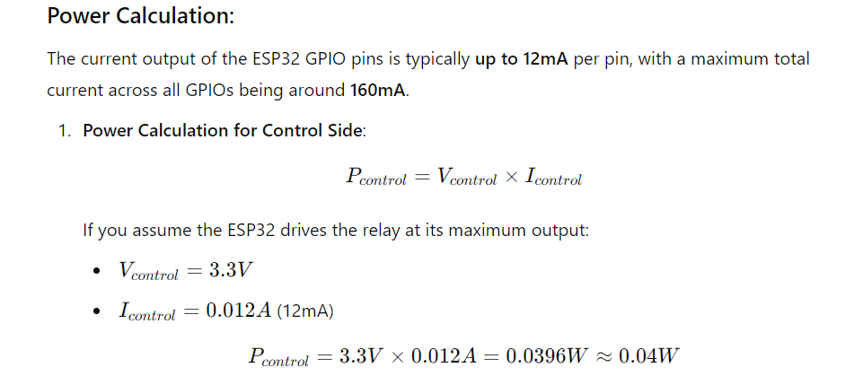
Summary:
- You can use the ESP32 output (3.3V) to control the D2440B relay.
- The power consumption of the relay's control input from the ESP32 is approximately 0.04W.

Conclusion:
Connecting the ESP32 to the D2440B is feasible and should work correctly as per the specifications provided.

